Parameterizing Builds SOP



Table of Contents

1. Parameterizing Builds 3
1.1 Description 3
1.2 Architecture Diagram 3
1.3 Lab Steps 4
1.3.1 Innovation 8
1.4 Supporting References 10

Parameterizing Builds

Description
Jenkins is an extensible open source continuous integration server. Using Jenkins we can perform the tasks automatically from our server or localhost. A script is created and built just once. Then, you can run the script by just clicking on Build link in Jenkins. The scripts can be scheduled using Jenkins. Build parameters can be used to store configuration options or data that should not live in source code.
The main objective of this lab exercise is to build a project that requires parameter. You will create a Freestyle project and update it to accept a string parameter.

Architecture Diagram
The diagram below displays a visual representation of the application architecture:
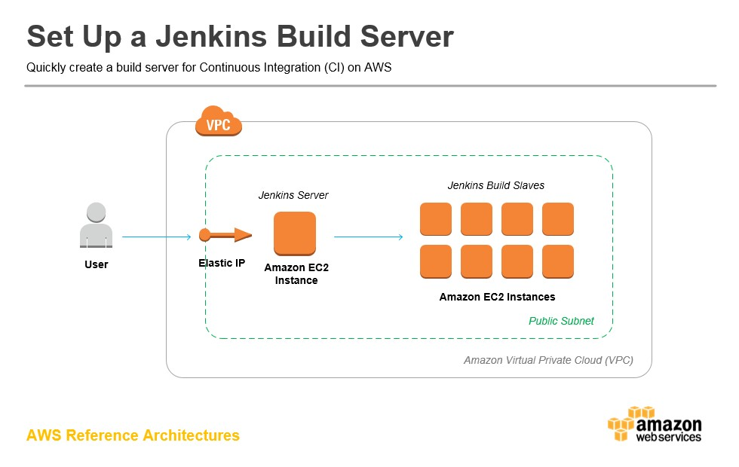

Lab Steps
Follow the steps outlined below to achieve the objective of this lab exercise:

- Create a Linux EC2 instance and install Jenkins.
Note: To perform this step, follow the steps outlined in the DevOps Beginner SOP - Installing Jenkins.
- Create a basic project to add the parameters:
  - Create a new job by entering the item name as Usecase5 and choose the Freestyle project.
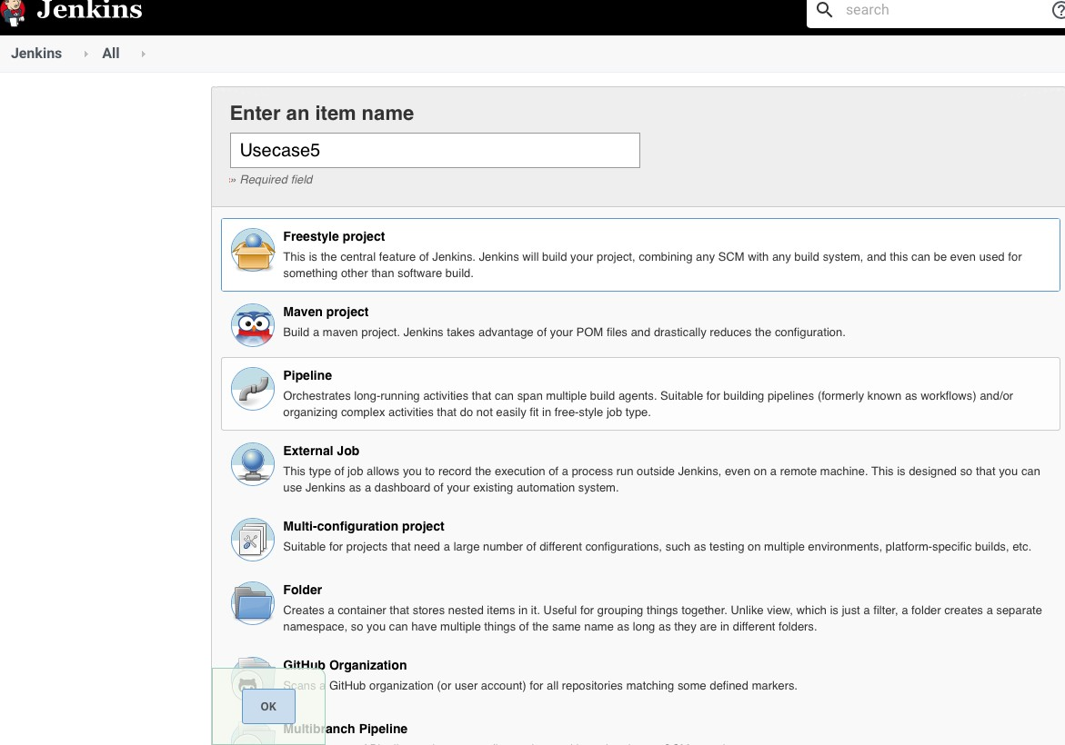

  - Click OK.
  - In the configuration page, select the checkbox - This project is parameterized.
  - Create string parameters:

Name | FIRST_NAME
Default Value | Harvey
Description | Default value Harvey

  - Add another string parameter
Name | LAST_NAME
Default Value | Specter
Description | Default value Specter
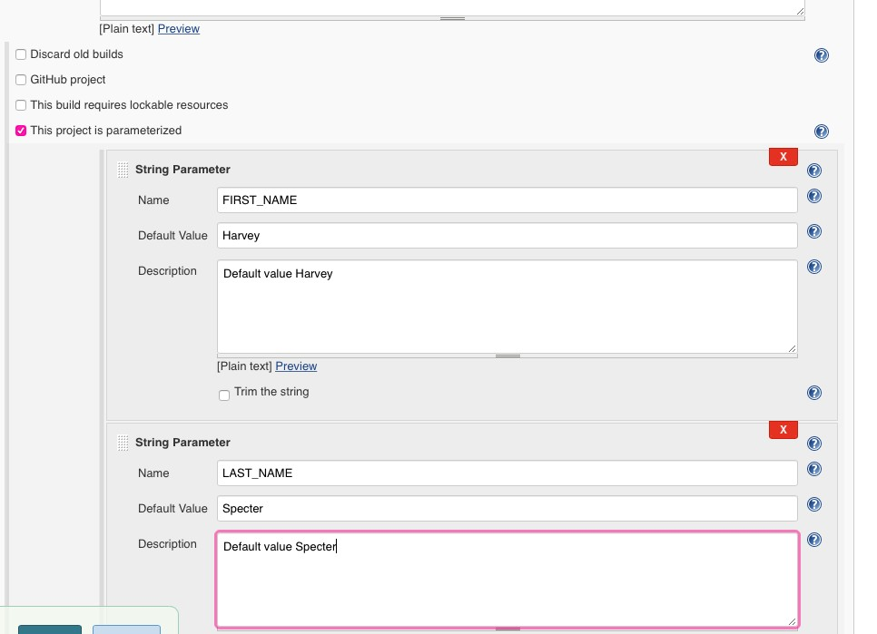

  - Go to the Build section, and add a Build Step – Execute Shell and type the following command (Execute shell to print the names)
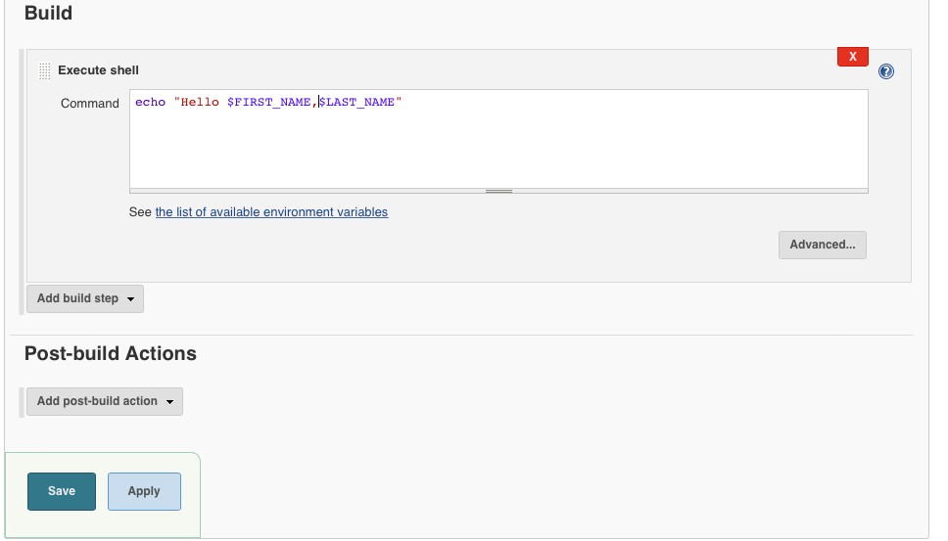
echo “Hello $FIRST_NAME,$LAST_NAME”

  - Click Save.
  - Build the project and check if the output is similar to the following:
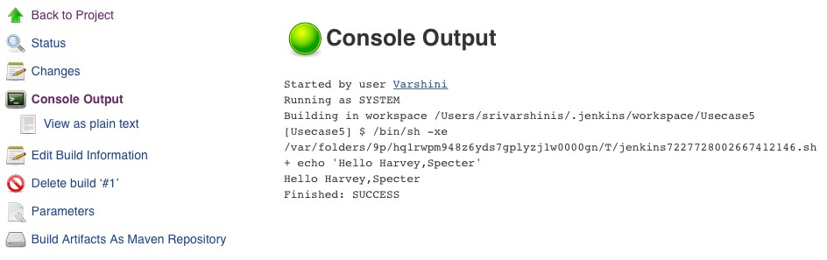

- Accept a string parameter:
    - Go to the configure page of the project and make the following changes:
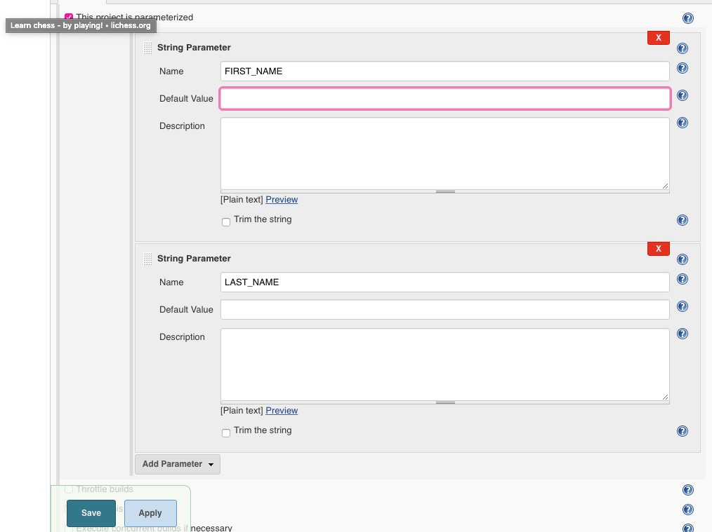

    - Build the project again, you will be prompted with this page
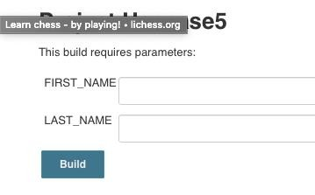

    - Enter the names:
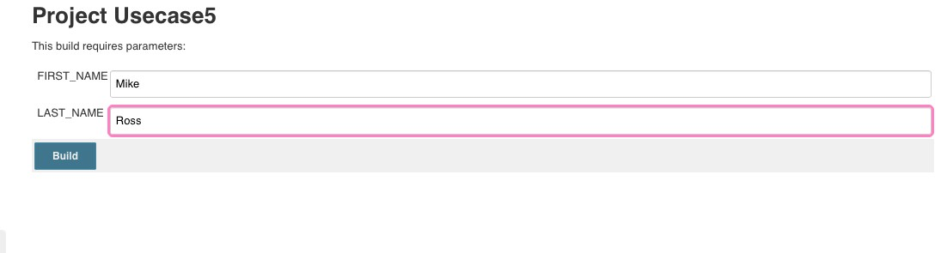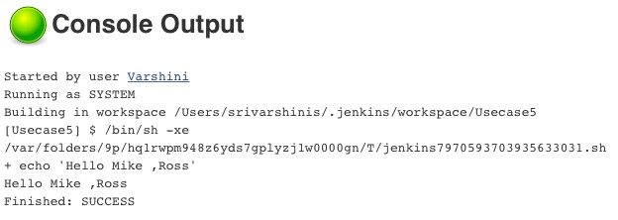
Note
:

The input gets accepted and is printed.

d.

Verify the output from the Console Output
:

Innovation

- Navigate to the configure page and add a new Choice Parameter to list a set of options before the Jenkins build Note: Replace the String Parameter LAST_NAME with a new Choice parameter called LAST_NAME.
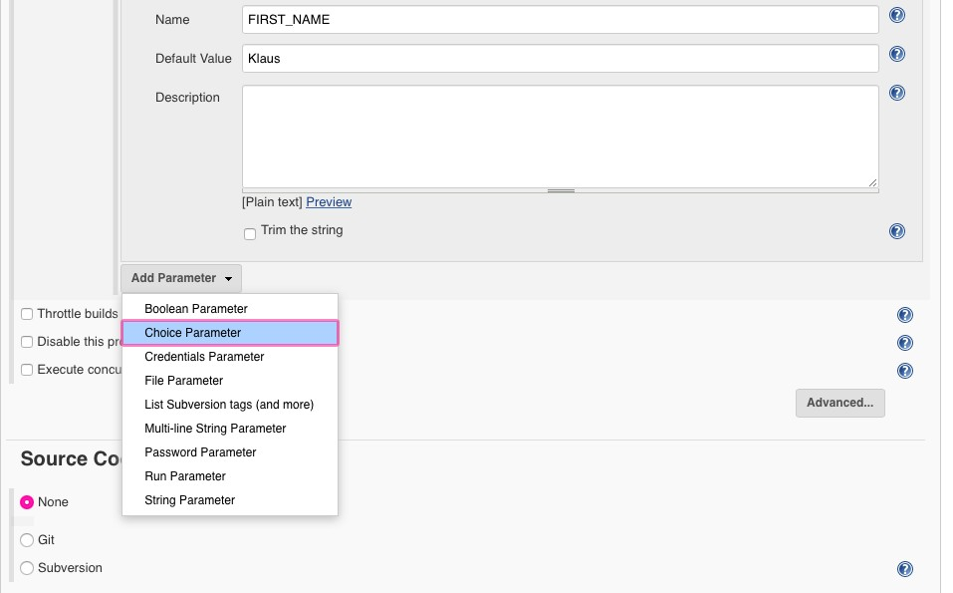

- Give in the choices for the last names and click Save.
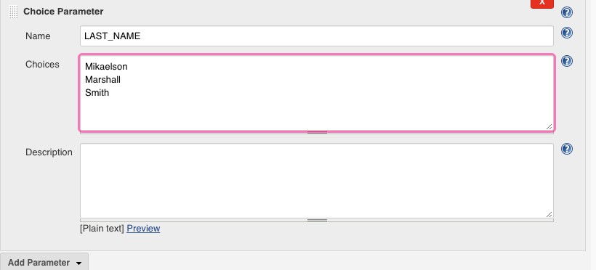

- Click Build with Parameters, and you will be prompted with the list of last names as in a dropdown menu.
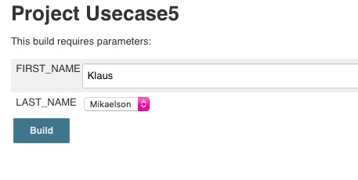

- The output changes every time you choose a different last name.
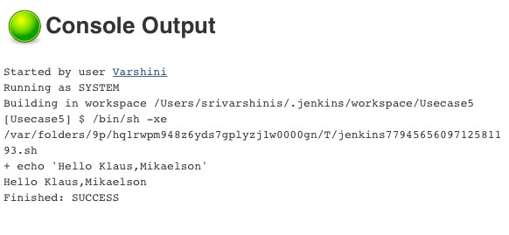
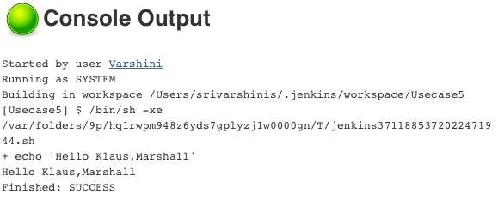

Supporting References
Refer the below links for additional information:

- https://www.tothenew.com/blog/building-parameterized-script-in-jenkins/
- https://linuxize.com/post/how-to-install-jenkins-on-centos-7/'
- https://medium.com/@anusha.sharma3010/jenkins-installation-on-linux-af36ad6bd629
- https://codingbee.net/uncategorized/yum-error-public-key-for-rpm-is-not-installed
- https://cognizantonline.sharepoint.com/sites/Academy-cms/LS/MLCV-2020-496/DevOps-Beginner-SOP--Installing-Jenkins.pdf

